Exercise 5 – Implementing the Decorator Pattern

Scenario
Develop a notification system that can dynamically add Email, SMS, and Slack notifications using the Decorator Pattern.

Understanding the Decorator Pattern
The Decorator Pattern allows additional responsibilities to be attached to an object dynamically without modifying its structure.

Project Name
DecoratorPatternExample

Implementation
interface Notifier{
void send();
}
class EmailNotifier implements Notifier{
public void send(){
System.out.println("Sending Email Notification...");
}
}
abstract class NotifierDecorator implements Notifier{
protected Notifier notifier;
NotifierDecorator(Notifier notifier){
this.notifier=notifier;
}
}
class SMSNotifierDecorator extends NotifierDecorator{
SMSNotifierDecorator(Notifier n){ super(n); }
public void send(){
notifier.send();
System.out.println("Sending SMS Notification...");
}
}
class SlackNotifierDecorator extends NotifierDecorator{
SlackNotifierDecorator(Notifier n){ super(n); }
public void send(){
notifier.send();
System.out.println("Sending Slack Notification...");
}
}
public class DecoratorTest{
public static void main(String[] args){
Notifier notifier =
new SlackNotifierDecorator(
new SMSNotifierDecorator(
new EmailNotifier()));
notifier.send();
System.out.println("\nNotification sent successfully using Decorator Pattern.");
}
}

Sample Output
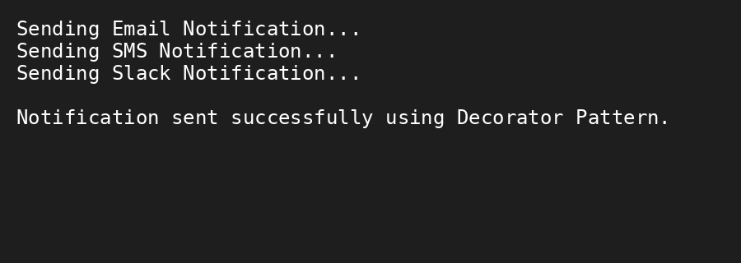

Conclusion
The Decorator Pattern makes it easy to add new notification channels dynamically without changing the existing classes.

